Mary Gellatly
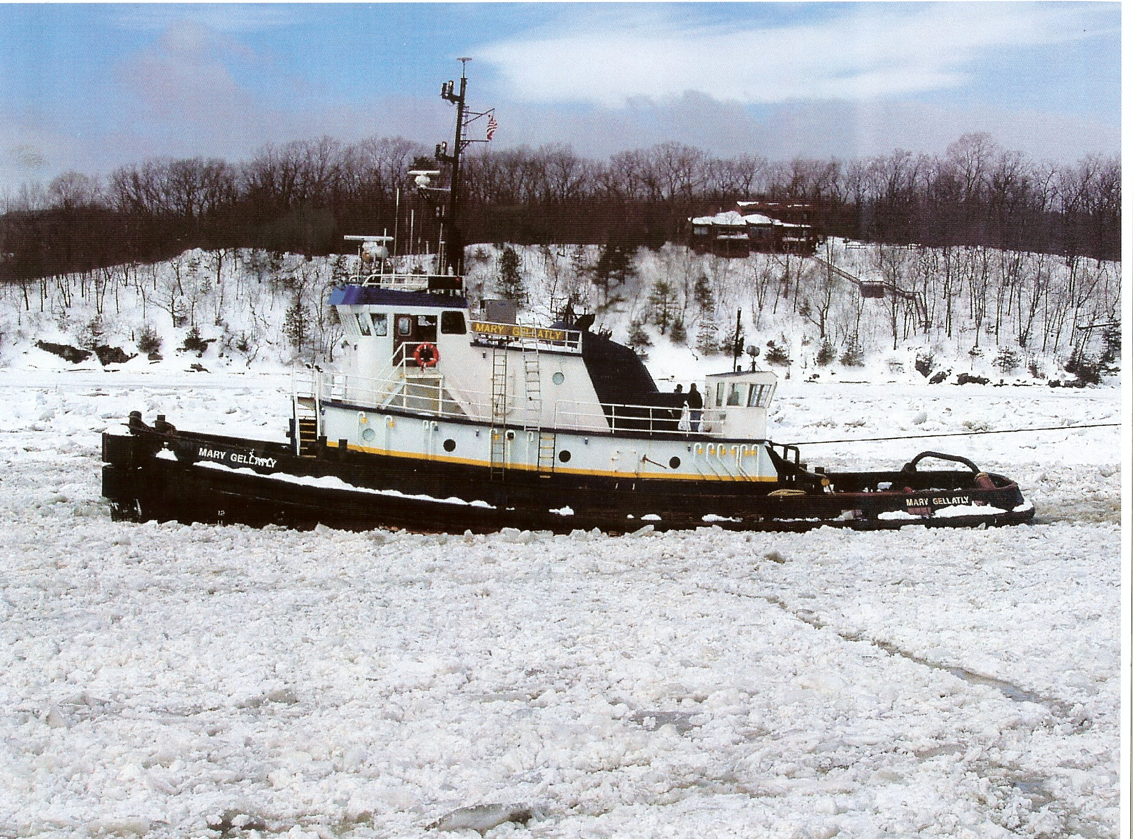
Dimensions & Regulatory Information:
Length: 100 ft.
Beam: 30 ft.
Depth: 14 ft.
Highest Point: 34 ft.
Man/Min Draft: 13.5 ft. / 13 ft.
Tonnage: Gross: 187 GRT Net: 127 NRT
Classification: American Bureau of Shipping, Loadline Only
Call Sign: WDA 4911
Official Number: 592075
Home Port: New Orleans, LA
ABS ID No.: 7817466
Hull No.: 582
Year Built: 1978
Shipyard: Halter Marine – New Orleans, LA

Propulsion, Auxillary Machine & Steering:
Main Engines: CAT D-399 16 Cylinder
Horsepower Total: 2200 BHP
Main Reduction Gears: Reintjes
Gear Ratio: 6:1
Propeller: Fixed Pitch, High Efficiency, 4 Blade
Size, Pitch x Diameter: 100 in. x 76 in.
Generators: Two (2) GM 6-71
Rating: 75 kw
Rudders: Two (2)
Tow Drum Wire: 2000 ft. x 1.75 in.
Towing Winch: Double Drum
Tow Winch Engine: GM 6-71

Capacities & Delivery Rates:
Fuel Oil: 30,000 USG
Lube Oil Storage: 550 USG
Potable Water: 5,400 USG
Dirty Oil/Slops: 3,000 USG

Features:
Roller Chocks Cathodic Protection System
Molded Rubber “D” Fendering System Forward Deck Sheaves
Dutch Bar Stern Rollers
Stockless Anchor FM-200 Fire Suppression System in
Engine Room

Electronics:
Chart Plotter with DGPS Interface Engine Systems Monitor
Northstar GPS Cell Phone
Fax Machine 2 Radars
E-Mail Capabilities Furuno Weather Fax
Anemometer Tow Winch Alarm
Gyro Compass Auto Pilot
Fathomater Single-side Band
VHF-FM (4)

